INDEX

Contents

**20 Best Places To Visit In Diu** 3

**1. Naida Caves – Explore The Rock Formations** 4

**2. Diu Fort – Must-Visit Place** 5

**3. Nagoa Beach – Laze Around** 6

**4. Gangeshwar Mahadev Temple – Seek Blessings** 8

**5. Ghoghla Beach – Soak In Sun Warmth** 9

**6. Zampa Gateway – Monument Of National Importance** 10

**7. INS Khukri Memorial – Plunge Into The History** 12

**8. Sunset Point – Witness The Changing Hues Of Sky** 13

**9. St. Paul Church – Largest Church In Diu** 14

**10. Sea Shell Museum – See Colorful Seashells** 15

**11. Dinosaur Park – Fun Place For Kids** 16

**12. Simbor Beach – Watch The Waves Clashing** 18

**13. Chakratirth Beach – A Secluded Place** 19

**14. Jallandhar Beach – Go For Water Sports** 20

**15. Gomtimata Beach – Spend Some ‘Me-Time’** 21

**16. Church Of St. Francis Of Assisi – Pay A Visit** 22

**17. Diu Museum – A Restored Church** 23

**18. Hoka Trees – Spend Some Time With Nature** 24

**19. Panikota Fort – The Jail Of Diu** 25

**20. Chapel Of Our Lady Rosary – Admire The Architecture** 26

LIST OF FIGURES

Figure 1: NAIDA CAVES 4

Figure 2: DIU FORT 6

Figure 3: NAGOA BEACH 7

Figure 4: GANGESHWAR MAHADEV TEMPLE 8

Figure 5: GHOGHLA BEACH 10

Figure 6: ZAMPA GATEWAY 11

Figure 7: INS KHUKRI MEMORIAL 12

Figure 8: SUNSET POINT 14

Figure 9: ST. PAUL CHURCH 15

Figure 10: SEA SHELL MUSEUM 16

Figure 11: DINOSAUR PARK 17

Figure 12: SIMBOR BEACH 18

Figure 13: CHAKRATIRTH BEACH 19

Figure 14: JALLANDHAR BEACH 20

Figure 15: GOMTIMATA BEACH 21

Figure 16: CHURCH OF ST. FRANCIS OF ASSISI 22

Figure 17: DIU MUSEUM 23

Figure 18: HOKA TREES 25

Figure 19: PANIKOTA FORT 26

Figure 20: CHAPEL OF OUR LADY ROSARY 27

**20 Best Places To Visit In Diu**

Do not miss out on these most-suggested places to visit in Diu during your sightseeing trip or you will have a major FOMO. Each place you’ll visit in Diu are going to make your whole travel experience worthwhile as well as memorable. Put these awesome places to explore in Diu on your itinerary right away so that you are not stuck in a last minute research while compiling your trip plan.

* **Naida Caves**– Explore The Rock Formations
* **Diu Fort**– Must-Visit Place
* **Nagoa Beach**– Laze Around
* **Gangeshwar Mahadev Temple**– Seek Blessings
* **Ghoghla Beach**– Soak In Sun Warmth
* **Zampa Gateway**– Monument Of National Importance
* **INS Khukri Memorial**– Plunge Into The History
* **Sunset Point**– Witness The Changing Hues Of Sky
* **St. Paul Church**– Largest Church In Diu
* **Sea Shell Museum**– See Colorful Seashells
* **Dinosaur Park**– Fun Place For Kids
* **Simbor Beach**– Watch The Waves Clashing
* **Chakratirth Beach**– A Secluded Place
* **Jallandhar Beach**– Go For Water Sports
* **Gomtimata Beach**– Spend Some ‘Me-Time’
* **Church Of St. Francis Of Assisi**– Pay A Visit
* **Diu Museum**– A Restored Church
* **Hoka Trees**– Spend Some Time With Nature
* **Panikota Fort**– The Jail Of Diu
* **Chapel Of Our Lady Rosary**– Admire The Architecture

# **1. Naida Caves – Explore The Rock Formations**

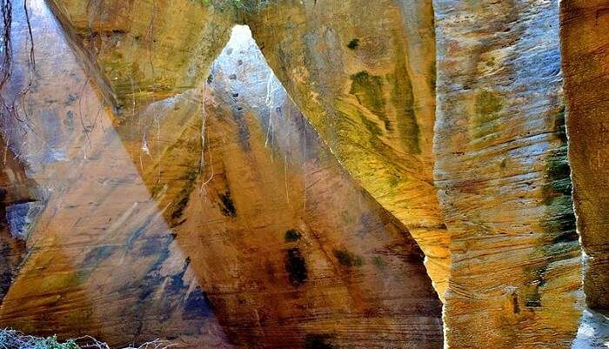

Figure : NAIDA CAVES

[Image Source](https://commons.wikimedia.org/wiki/File:Naida_caves_in_diu_,_india.jpg)

These natural cave formations are actually a work of man-made rock modifications over the time by the Portuguese people and served as the base camps for Indian Army during the operation Vijay to reclaim Diu from Portuguese people. These famous tourist places in Diu have various interlinked areas with square-shaped hewn staircases. Naida Caves are located right outside the city boundaries of Diu just 3 km away from the main city and are one of the most famous places to visit in Diu.

**Location:** Diu, Daman and Diu 362520  
**Timings:** 10 AM to 2 PM  
**Entry Fee**: Free  
**How to reach:** Diu Airport is just 9 KM from the caves and travellers can reach here via buses or taxis etc. The caves are located near the bus-stand and many people go on foot. You can arrive at the Una railway station and arrive here via buses or hired conveyance.  
**Best time to visit:** Diu is a coastal region that stays hot and windy all year. Summers are hot and humid and monsoons become oppressively humid. Winters span from November to February and are the best time to visit. Average annual temperature is 26 degree Celsius.

**Must Read:** [5 Best Beach Resorts In Diu For Experiencing Luxury On A Budget](https://traveltriangle.com/blog/best-beach-resorts-in-diu/)

**Book Top-rated Hotels**

100% Verified Stays

No Booking Fees

35K + Reviews by Travellers

* 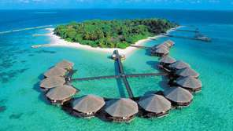

**UPTO 40% OFF**

**Andaman**

20 top-selling hotels

**From ₹ 2,000**Per Night

[**View Hotels**](https://traveltriangle.com/hotels/andaman?utm_source=blog_hotel_slider)

* 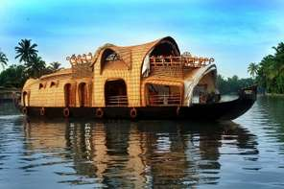

**UPTO 30% OFF**

**Kerala**

18 top-selling hotels

**From ₹ 1,800**Per Night

[**View Hotels**](https://traveltriangle.com/hotels/kerala?utm_source=blog_hotel_slider)

* 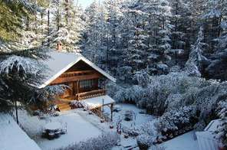

**UPTO 35% OFF**

**Himachal**

19 top-selling hotels

**From ₹ 1,000**Per Night

[**View Hotels**](https://traveltriangle.com/hotels/himachal?utm_source=blog_hotel_slider)

* 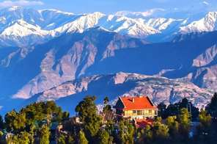

**UPTO 40% OFF**

**Kashmir**

20 top-selling hotels

**From ₹ 1,400**Per Night

[**View Hotels**](https://traveltriangle.com/hotels/kashmir?utm_source=blog_hotel_slider)

* [Previous](https://traveltriangle.com/blog/places-to-visit-in-diu/)
* [Next](https://traveltriangle.com/blog/places-to-visit-in-diu/)

# **2. Diu Fort – Must-Visit Place**

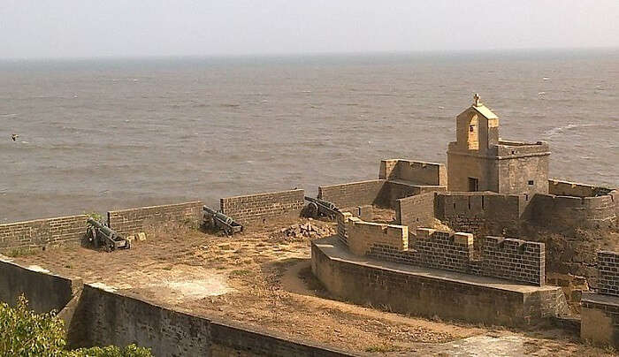

Figure : DIU FORT

[Image Source](https://commons.wikimedia.org/wiki/File:Diu_fort_Diu_india.jpg)

Fort Diu is located right beside the sea or on the sea shore and is one of the most iconic places to visit in Diu. You can enjoy a surreal view of the horizons from the fort and hear the crashing sea waves on the fort walls sending foam to its upper reaches! The lighthouse is closed to the public. The fort was built by the Portuguese people and its jetty is still in use. The fort was once an important entity on the trade route with Cambay, Surat and Bharuch in Gujarat. The parapet has an array of cannons and cannonballs are littered around the entire land surrounding the fort.

**Location:** Fort Road, near to PWD Office, Diu, Daman and Diu 362520  
**Timings:** 8 AM – 6 PM  
**Entry Fee**: Free  
**How to reach:** Diu Airport is just 10 KM from the fort. So, you can come in a bus, taxi or car rental as per your choice. Una is the nearest railway station located at just 12 KM from Diu. You can reach Diu and then Diu Fort via a car, Taxi or bus from the Una Railway Station.  
**Best time to visit:** The weather is humid and hot with 26 degrees Celsius being the average annual temperature in Diu. The best time to explore Diu Fort is in winter i.e. November-February when the temperature falls below 20 degree Celsius.

**Suggested Read:** [52 Intriguing Tourist Places In Ahmedabad For Your Gujarat Getaway](https://traveltriangle.com/blog/tourist-places-in-ahmedabad/)

# **3. Nagoa Beach – Laze Around**

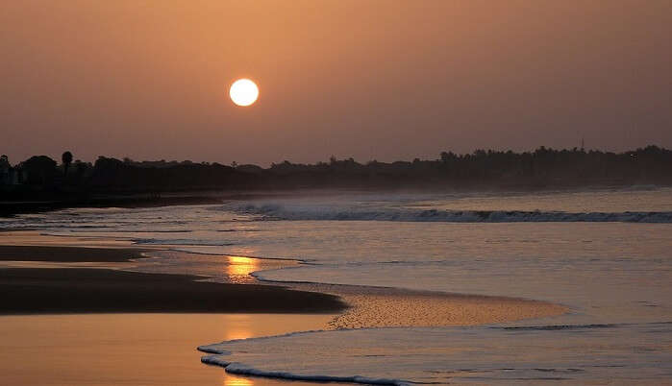

Figure : NAGOA BEACH

[Image Source](https://www.maxpixels.net/Sunrise-Shore-Water-Nature-Sea-Beach-Ocean-2690145)

Nagoa Beach is one of the most famous places to visit in Diu and is home to stunning vast expanses of sand etched with trees and bounded with the warm waters of the Arabian Sea. Nagoa Beach offers the best beach experience in Diu and is home to the rare Hoka Trees, one of the most fascinating Diu sightseeing places. You can enjoy lots of [adventure sports in Diu](https://traveltriangle.com/blog/adventure-sports-in-diu/) along with thrilling rides on camels and ponies. Sunsets, sunrises, long beach walks, peaceful areas, and local restaurants for enjoying local food, and many luxurious [villas in Diu](https://traveltriangle.com/blog/villas-in-diu/) – Nagoa beach is wonderful!

**Location:** Diu, Daman & Diu  
**Timings:** Sunrise and Sunsets  
**Entry Fee**: Free  
**How to reach:** Nagoa Beach is near the Airport and can be reached via public or private conveyance easily. You can arrive at the beach after arriving at the Una Railway Station. Public conveyance or car rentals are easily available.  
**Best time to visit:** November to early March is the best time to visit the beach. It is perfect for serene beach outings and you can also enjoy peaceful evenings here.

**Suggested Read:** [Shopping In Gujarat: 10 Incredibly Awesome Places That Will Tempt You To Splurge More!](https://traveltriangle.com/blog/shopping-in-gujarat/)

# **4. Gangeshwar Mahadev Temple – Seek Blessings**

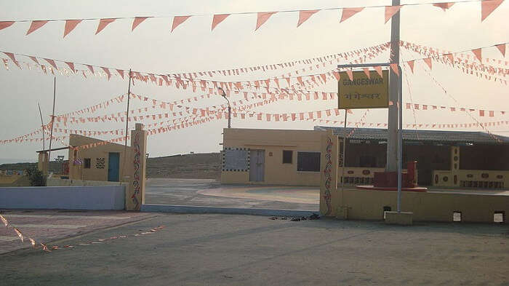

Figure : GANGESHWAR MAHADEV TEMPLE

[Image Source](https://hi.wikipedia.org/wiki/%E0%A4%9A%E0%A4%BF%E0%A4%A4%E0%A5%8D%E0%A4%B0:Gangeshwar_Temple,Diu.jpg)

Gangeshwar Mahadev Temple is one of the top places to visit in Diu and is very famous among the tourists. River Ganga is the presiding deity of the temple that is supposed to have been built by the Pandavas. The temple is famous for the five SHIV LINGAS. Only their tips are visible and high tide covers them entirely at times. The temple is located in Fudam Village which is just 3 km from Diu. The place has immense religious and historical importance and is located in a scenic location.

**Location:** Diu, Daman and Diu 362520  
**Timings:** 8 AM – 6 PM  
**Entry Fee**: Free **How to reach:** Arrive at Diu Airport which is just 5 km from the temple. You can arrive at the temple via public or private conveyance which is easily available. Arrive at the Una Railway Station which is 12 km from Diu and reach Diu via public or private transport. Take an auto or any other conveyance of your choice to reach the temple.  
**Best time to visit:** October to May is the best time for the visitors. The average temperature varies from 20 degree Celsius to 26 degree Celsius with warm coastal winds being present throughout the year.

**Suggested Read:** [Top 8 Places To Visit In Gujarat During Monsoon To Enjoy This Season](https://traveltriangle.com/blog/places-to-visit-in-gujarat-during-monsoon/)

# **5. Ghoghla Beach – Soak In Sun Warmth**

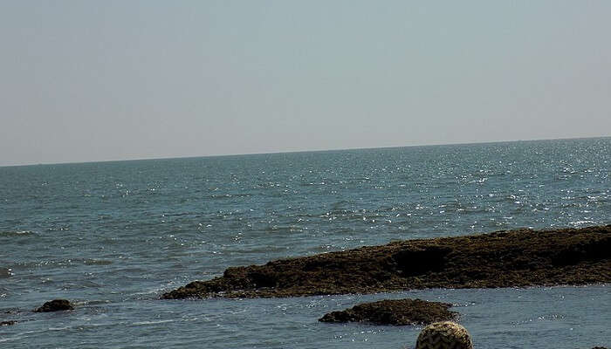

Figure : GHOGHLA BEACH

[Image Source](https://commons.wikimedia.org/wiki/File:Beauty_of_diu.jpg)

Ghoghla Beach is one of the most famous places to explore in Diu and is famous among the locals and tourists alike. Ghoghla Beach is home to stunning coastal beauty and is a perfect destination for soul-searching as there is no crowd here. You can calmly soak in the warm sun and let the winds waft away your worries and tensions gradually. Out of many other Diu famous places, this beach is clean, has restaurants, offers water sports, and has many famous [homestays of Diu](https://traveltriangle.com/blog/homestays-in-diu/).

**Location:** Diu, Daman & Diu  
**Timings:** NA  
**Entry Fee**: Free  
**How to reach:** The beach is just 10 KM away from the airport and can be reached via taxi or auto. Hire a taxi or travel via public buses from Una Railway Station to reach Diu which is just 12 km from the station. From here, you can reach the beach easily by any means of your choice.  
**Best time to visit:** Late October to March or early April is the time when the temperature is right and summers are not harsh. You can visit the beach to witness the splendid sunsets and sunrises as well. The temperature varies from 20 degree Celsius to 26 degree Celsius in the winter and early summer. Summers are very hot and humid.

**Suggested Read:** [10 Best Places To Visit In Gujarat In Summer For An Enthralling Holiday](https://traveltriangle.com/blog/places-to-visit-in-gujarat-in-summer/)

# **6. Zampa Gateway – Monument Of National Importance**

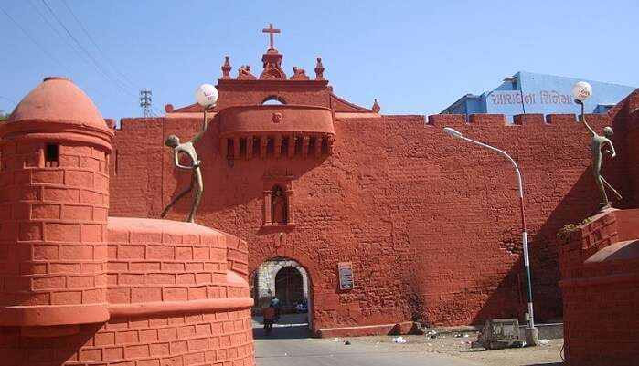

Figure : ZAMPA GATEWAY

[Image Source](https://commons.wikimedia.org/wiki/File:View_of_Zampa_Gateway.JPG)

Zampa Gateway is also one of the best places to visit in Diu that has a lot of history associated with it. The bright red construction is a monument of national importance and has an artificial waterfall as well. The monument is thronged by tourists every year. Its walls have paintings of lions, ministers and heavenly attendants. There is a simple chapel as well with a picture of the Virgin Mary and a child that dates back to 1702.

**Location:** Diu, Daman & Diu  
**Timings:** Open 24 hours  
**Entry Fee**: Free  
**How to reach:** After arriving at the Diu Airport, you can board the public transport or private conveyance to reach the attraction. Disembark at Una Railway Station and then travel to Diu by public or private conveyance which is easily available. You can board a taxi or auto from Diu city to Zampa Gateway.  
**Best time to visit:** Late October to April is the best time to visit Diu and Zampa Gateway. Average annual temperature varies from 20 degree Celsius to 26 degree Celsius in colder months. Summers are very hot and the rainy season is very humid.

**Suggested Read:** [17 Historical Places In Gujarat That Uncover A Legendary Past](https://traveltriangle.com/blog/historical-places-in-gujarat/)

# **7. INS Khukri Memorial – Plunge Into The History**

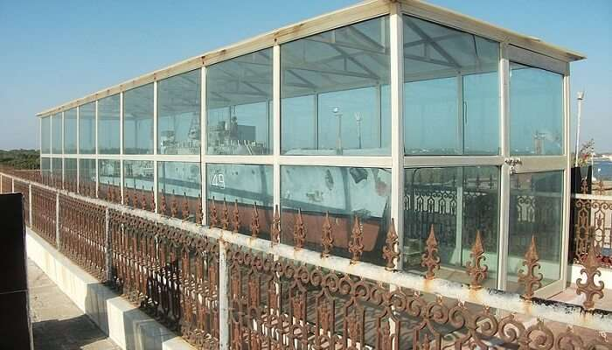

Figure : INS KHUKRI MEMORIAL

[Image Source](https://commons.wikimedia.org/wiki/File:Model_of_INS_Khukri_at_memorial_of_the_ship,_2012.jpg)

INS Khukri Memorial is a monument built commemorating the INS Khukri that sunk during the 1971 war between Pakistan and India. The submarine was shot with torpedoes and started to sink when the 18 officers and 176 sailors on it were issued the orders to save their lives and hand them over to the invaders. However, the officers chose to embrace death rather than surrendering to the enemies. Later the commanding officer Captain Mahendra Nath Mulla was awarded Mahavir Chakra posthumously. The monument stands till date a reminder of the valiant soldiers, and is visited by many tourists every year.

**Location:** Diu, Daman and Diu 362520  
**Timings:** Open 24 hours  
**Entry Fee**: Free **How to reach:** From Diu Airport you can board the public or private transport to reach the Diu city and then arrive at the INS Khukri Memorial. Arrive at Una Railway Station which is 12 KM from Diu. From Diu city, you can reach the memorial via private or public conveyance.  
**Best time to visit:** November to March is the best time to visit the memorial. We recommend visiting the memorial during day time. The temperature varies from 20 degree Celsius to 26 degree Celsius in the tourist season.

**Suggested Read:** [7 Haunted Places In Gujarat That Will Scare You Out Of Your Wits](https://traveltriangle.com/blog/haunted-places-in-gujarat/)

# **8. Sunset Point – Witness The Changing Hues Of Sky**

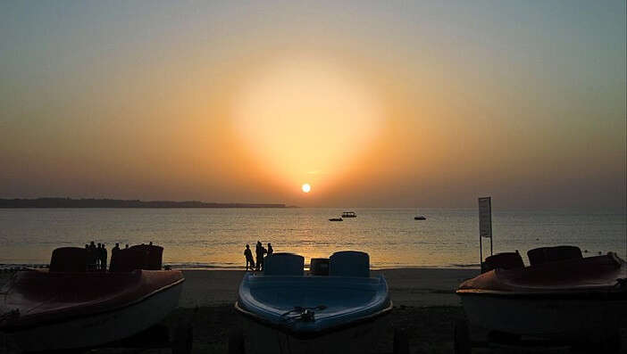

Figure : SUNSET POINT

[Image Source](https://commons.wikimedia.org/wiki/File:Sunset_at_Diu_Island.jpg)

Sunset Point is also one of the famous places here that is also one of the best places to visit in Diu at night. The sunset point is a hillock located near Chakratirth Beach, and is a dreamy place to witness the surreal beauty of sunset. Waves crashing on the rocks; and rocks merging gradually with the water – the sunset point is a stunning scenery at the time of sunrise and sunset.

**Location:** Daman and Diu 362570  
**Timings:** Open 24 hours  
**Entry Fee**: Free  
**How to reach:** After arriving at Diu Airport, you can board the public or private conveyance to reach Diu city. From here you can board autos or taxis to Sunset Point. Una Railway Station is the nearest railway station from where you can find private or public vehicles for Diu City or Sunset Point.  
**Best time to visit:** October to Late March or April is the best time to visit Diu and Sunset Point. The average annual temperature is 26 degree Celsius with humidity and winds being an annual feature.

**Suggested Read:** [10 Exciting Things To Do In Saputara To Make Your Gujarat Getaway More Fun!](https://traveltriangle.com/blog/things-to-do-in-saputara/)

# **9. St. Paul Church – Largest Church In Diu**

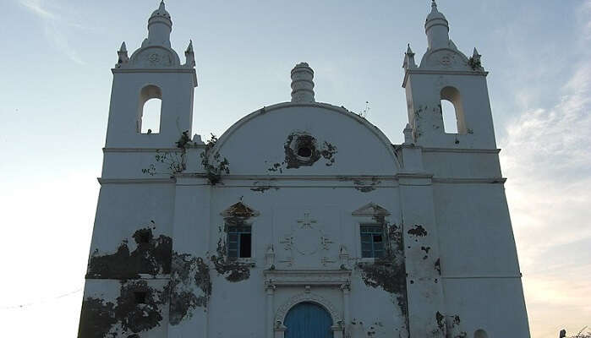

Figure : ST. PAUL CHURCH

[Image Source](https://commons.wikimedia.org/wiki/File:St._Thomas_Church,_Diu.jpg)

St. Paul Church is the largest church in Diu which is also the only functional church here. The building has a stunning architecture and has rich wood carvings, volutes and marvellous exterior. The church is dedicated to Our Lads of Immaculate Conception and was completed in 1601 AD. The church is visited by many tourists all around the year.

**Location:** Diu, Daman and Diu 362520  
**Timings:** 8 AM to 6 PM  
**Entry Fee**: Free  
**How to reach:** Diu Airport is located at a distance of 8 KM and you can reach the church via public or private conveyance.Arrive at Una Railway Station and hire a taxi or auto to reach Diu. From Diu city, you can reach the Church easily via roads.  
**Best time to visit:** November to March is the tourist season of Diu. The average annual temperature is 26 degree Celsius with hot and humid summers.

**Suggested Read:** [17 Famous Festivals In Gujarat To Celebrate  With Joyous Fervor](https://traveltriangle.com/blog/festivals-in-gujarat/)

# **10. Sea Shell Museum – See Colorful Seashells**

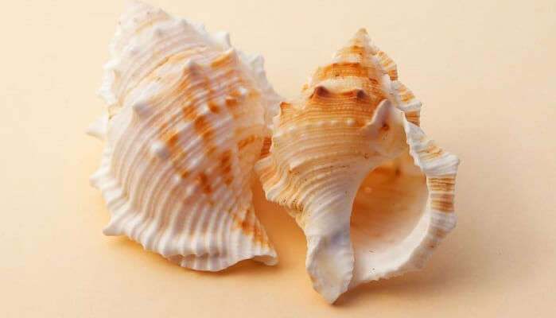

Figure : SEA SHELL MUSEUM

[Image Source](http://www.peakpx.com/545993/2-white-and-brown-conch-shell)

Sea Shell Museum is one of the top places to visit in Diu that offers an engrossing display of artefacts and objects dating back to the past of Diu. The Sea Shell Museum has a vast collection of different kinds of sea shells and is loved by kids as well. It is an engaging place to visit with your kids and family.

**Location:** Nagoa Beach Rd, Daman and Diu 362570  
**Timings:** 10 AM – 5 PM  
**Entry Fee**: Free  
**How to reach:**The travelers can board the public and private conveyance to reach the museums as they are well-connected via roads. Arrive at Una Railway Station which is 12 KM from Diu. From Diu city, you can reach the memorial via private or public conveyance.  
**Best time to visit:** October to April

**Suggested Read:** [17 Things To Do In Daman That Will Make You Crave For A Vacation At This Tropical Paradise!](https://traveltriangle.com/blog/things-to-do-in-daman/)

# **11. Dinosaur Park – Fun Place For Kids**

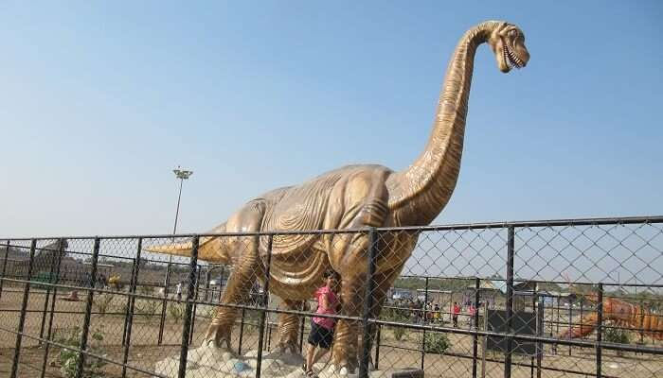

Figure : DINOSAUR PARK

[Image Source](https://commons.wikimedia.org/wiki/File:Dinosaur_Park_and_Children_Play_area.jpg)

The Dinosaur Park in Diu is a rather recent addition to the city’s terrain, and it has already turned into a major hit among families with kids and thrill seekers! This ultra innovative themed park for kids is among the best Diu tourist places and features life size dinosaur structures (as well as other prehistoric creatures) along with a large play area for kids without any restrictions on timings. Other than attractions for kids, the park also has a well-paved lane where the parents can relax or take a walk while the kids play.

**Location:** Near Nagoa Beach, Diu, Daman and Diu 362520  
**Entry fee:** INR 20  
**Timings:** 10 AM – 6 PM  
**How to reach:** You can take a bus to Nagoa Beach Road bus stand or a taxi to get to this point.  
**Best time to visit:** Year-round

**Suggested Read:** [These 16 Best Places To Visit In Daman Will Surely Make You Fall In Love With This Coastal City](https://traveltriangle.com/blog/best-places-to-visit-in-daman/)

# **12. Simbor Beach – Watch The Waves Clashing**



Figure : SIMBOR BEACH

Situated in the village of Simbor in Diu, the pleasant beach of Simbor boasts of unmatched serenity, soothing surroundings, and unparalleled beauty. Other than the sweeping picturesque vistas of the sea and the soft golden sands, the beach also features the Fort St. Anthony of Simbor, an old Portuguese fort that now lies in ruins, but still manages to attract people with its mystical charm and makes this beach one of the best tourist places in Diu.

**Location:** Simbor village, Diu, Gujarat  
**Timings**: Anytime  
**Entry Fee**: Free  
**How to reach:** You will need to hire a cab or bike to reach this beach from anywhere in Diu.  
**Best time to visit:** October – February

**Suggested Read:** [6 Places Near Daman One Must Visit To Enjoy The Paradisiacal Beauty Of The City!](https://traveltriangle.com/blog/places-near-daman/)

# **13. Chakratirth Beach – A Secluded Place**



Figure : CHAKRATIRTH BEACH

The lovable Chakratirth Beach is tucked on a secluded coast just on the outskirts of Diu. Nestled in the midst of serene hills that blend into the Arabian Sea at the base, this tranquil beach is an ideal location for those who wish to soak up the sun on empty shores or take a leisurely swim in these shallow waters. Since the weather remains cool here even in the summers, it’s one of the best places to see in Diu to beat the heat. The beach also has an open-air auditorium with changing rooms set at the nearby hillock.

**Location:** Khukhari, Diu  
**Timings**: Anytime  
**Entry Fee**: Free  
**How to reach:** You can hire a taxi or bike to reach this beach from anywhere in Diu.  
**Best time to visit:** October to March

**Suggested Read:** [8 Beautiful Villas In Daman That Offer The Best Views Of The Beach!](https://traveltriangle.com/blog/villas-in-daman/)

# **14. Jallandhar Beach – Go For Water Sports**

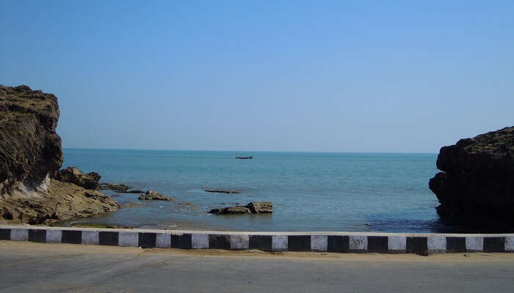

Figure : JALLANDHAR BEACH

[Image Source](https://commons.wikimedia.org/wiki/File:Road_from_Jalandhar_Beach_to_Ganeshwar_Mahadev_temple,_Diu.jpg)  
Lying 1 km away from the main city of Diu, the sunny Jalandhar Beach got its name from the notorious demon “Jallandhar” and is among the finest [places near Diu](https://traveltriangle.com/blog/places-to-visit-near-diu/). Apart from golden sands and pretty views of the ocean, this beach also has a temple and a memorial. The temple located here is dedicated to Goddess Chandrika whereas the memorial nestled on the top of a hill has a stone structure of the demon Jallandhar. But that’s not all that makes it one of the best places to visit in Diu. The beach is also famous for a number of thrilling water sports and even serves as a great location for a private photo shoot.

**Location:** Diu, Daman and Diu 362520  
**Timings**: Anytime  
**Entry Fee**: Free  
**How to reach:** You can hire a taxi or bike to reach this beach from anywhere in Diu.  
**Best time to visit:** November to March

**Suggested Read:** [10 Hotels In Daman To Enjoy Your Stay In A Luxurious Way](https://traveltriangle.com/blog/hotels-in-daman/)

# **15. Gomtimata Beach – Spend Some ‘Me-Time’**

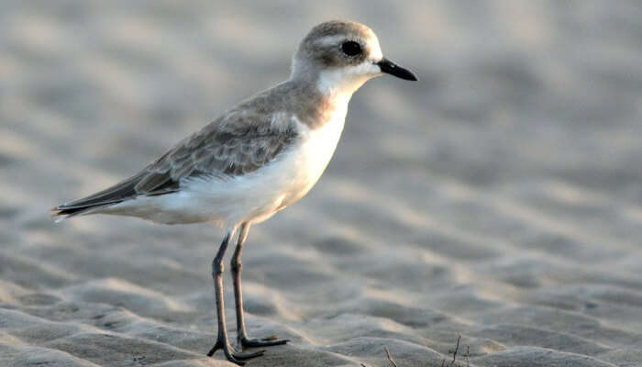

Figure : GOMTIMATA BEACH

Gomtimata Beach is among the best beaches in Diu and is located in Vanakbara village on the westernmost point of the Diu. It’s one of those Diu famous places that is absolutely secluded and is characterised by its natural white sand, tranquil surroundings, and expansive ocean views which make it perfect for a relaxing stroll, sunbathing, or any other activity you want to engage in during your ‘me-time’. There is also a famous temple located right next to this public beach.

**Location:** Vanakbara, Gomtimata, Daman and Diu 362570  
**Timings:** 6:30 AM – 7:30 PM  
**Entry Fee**: Free  
**How to reach:** You can hire a taxi or bike to reach this beach from anywhere in Diu.  
**Best time to visit:** October to April

**Suggested Read:** [7 Quixotic Homestays In Daman That You Can Opt For An Opulent Stay](https://traveltriangle.com/blog/homestays-in-daman/)

# **16. Church Of St. Francis Of Assisi – Pay A Visit**

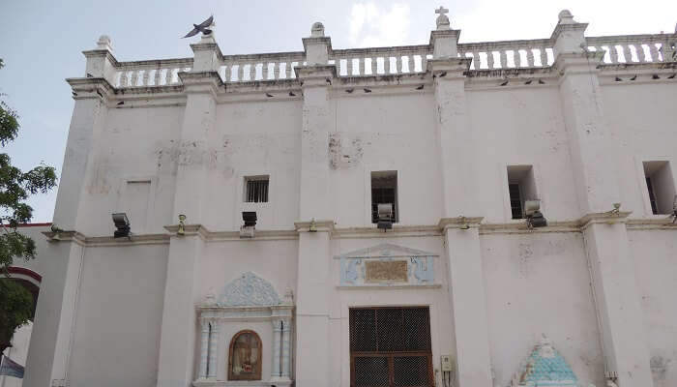

Figure : CHURCH OF ST. FRANCIS OF ASSISI

[Image Source](https://commons.wikimedia.org/wiki/File:St_Francis_of_Assisi_diu.JPG)

If you’re looking for Diu sightseeing places that can offer a blend of history and architecture, then you must visit the Church Of St. Francis Of Assisi, one of the oldest churches in Diu, Gujarat. It was built in 1593 and later converted into a hospital, before being restored to its marvelous Portuguese-era splendor only recently. As a testament to its long drawn history, it bears sea-spray decay in many parts that is enough to tell visitors how old it is! Its blue-white arches as well as the huge carved wooden altar with images of the Virgin make it one of the most beautiful places to explore in Diu.

**Location:** Unnamed Road, Gujarat, Diu, Daman and Diu 362520  
**Timings:** 7:30 AM – 6:30 PM  
**Entry Fee**: NA  
**How to reach:** A taxi or bus in Diu will take you here. You can also avail a shared cab or auto.  
**Best time to visit:** Year-round

**Suggested Read:** [10 Best Resorts In Diu You Must Consider When Looking For Accommodation Options](https://traveltriangle.com/blog/resorts-in-diu/)

# **17. Diu Museum – A Restored Church**

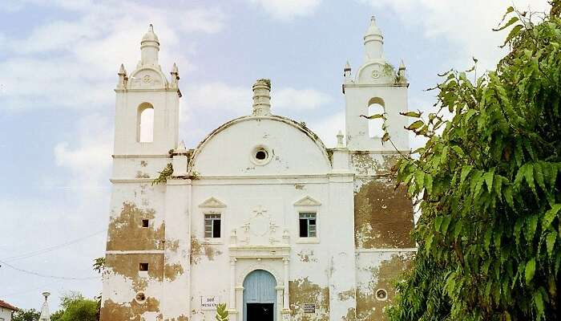

Figure : DIU MUSEUM

[Image Source](https://commons.wikimedia.org/wiki/File:Eglise_St_Thomas.jpg)

The Diu Museum is among the most famous Diu tourist places and is a part of the St. Thomas Church which was converted into a museum shortly after it was built in 1598. While the museum part is relatively new and well-kept, the church area has been allowed to restore its former glory and ancient look. You’ll find that the building bears a worn out look and has faded portraits and paintings that the Portuguese had left behind. You’ll also be mesmerised by the beautiful garden path that leads up to the museum, one of the most attractive places to see in Diu.

**Location:** Diu, Daman and Diu 362520  
**Entry fee:** Nil  
**Timings:** 8 AM – 9 PM  
**How to reach:** A taxi or bus in Diu will take you here. You can also avail a shared cab or auto.  
**Best time to visit:** Year-round

**Suggested Read:** [11 Amazing Diu Hotels That You May Want To Opt For Your Vacation!](https://traveltriangle.com/blog/diu-hotels/)

# **18. Hoka Trees – Spend Some Time With Nature**

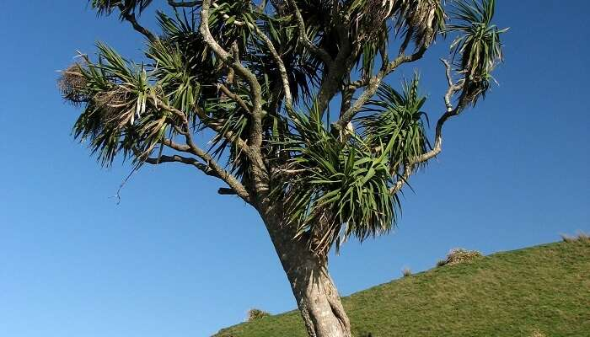

Figure : HOKA TREES

[Image Source](https://commons.wikimedia.org/wiki/File:CabbageTreeKaihoka.jpg)

The hoka trees are a native plant species of the northern half of Africa and some regions of the Arabian Peninsula. Which is why it always surprises people to find that a certain area of Diu also bears these blooming trees, which is, in fact, one of the most fascinating Diu tourist places! When you’re driving around on your Diu sightseeing tour, you may come across a large population of these trees near the Diu Fort which are easily distinguishable owing to their peculiar structure and beauty. You will even find that the enormous Hoka seed derived from these trees is cooked and consumed by many locals in the Diu and Saurashtra region. In fact, the local ‘Tadi’ is prepared using these seeds.

**Location:** Near Diu Fort, Diu, Gujarat  
**Timings:**NA **Entry Fee:**NA **How to reach:** You can take a taxi to Diu Fort and walk to the point where this tree is growing with the help of the signboards.  
**Best time to visit:** October to March

**Suggested Read:** [7 Hotels Near Diu That Ascertain A Pleasant Stay During Your Diu Trip](https://traveltriangle.com/blog/hotels-near-diu/)

# **19. Panikota Fort – The Jail Of Diu**

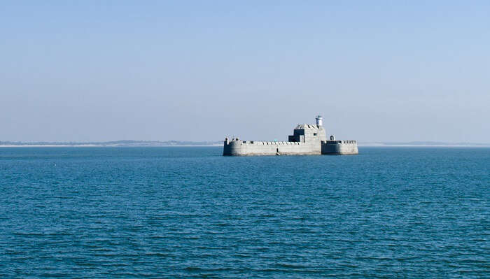

Figure : PANIKOTA FORT

[Image Source](https://commons.wikimedia.org/wiki/File:Panikota_fort,_Daman.jpg)

Otherwise called as Fortim-Do-Mar, Panikota Fort is a famous Diu jail that is located on an island in the bay of Simbor. The coast was located at a distance of approximately 46 kilometers from Diu. The fort was utilized as a jail post-independence from the Portuguese. As the island is surrounded by water from all sides, it was perfect for inmates as they could not escape. Make sure that you visit it at least once as it is one of the **famous places to visit in Diu**.

**Location**: Daman & Diu  
**Timings**: 8 AM – 6 PM  
**Entry Fee**: Free  
**How to reach**: The only way to reach Panikota Fort is by taking a ride in a canoe or a motor launch from Diu. This way, you can reach the destination within an hour.   
**Best time to visit**: October – April

**Suggested Read:** [5 Resorts Near Diu For All Those Who Love Basking On The Beach All Day Long!](https://traveltriangle.com/blog/resorts-near-diu/)

# **20. Chapel Of Our Lady Rosary – Admire The Architecture**

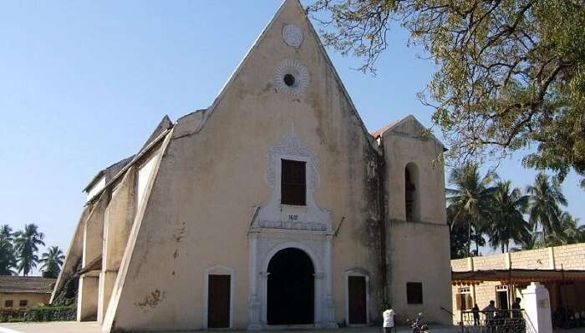

Figure : CHAPEL OF OUR LADY ROSARY

[Image Source](https://en.wikipedia.org/wiki/File:Front_View_of_Rosary_Church.jpg)

Nestled in Old Moti Daman, the establishment of this church can be dated back to the 17th century which is why it holds great significance and is counted among the **best places to visit in Diu**. The architecture is a reminiscence of Gothic-style architecture and Portuguese influence. The interior of the church is beautiful with rose-petal shaped roof and tinted glass windows that fill the chapel with beautiful colors in the daylight.

**Location**: Diu, Daman and Diu 362520  
**Timings**: NA  
**Entry Fee**: Free  
**How to reach**: The Chapel lies on Fort Road in Diu and it can be reached easily via a bike, cab or scooter drive. It is located at an approximate destination of 600 meters from St. Paul’s Church.   
**Best time to visit**: Throughout the year

**Further Read:** [International Kite Festival In Gujarat: Join The Uttarayan Celebrations This January](https://traveltriangle.com/blog/international-kite-festival-in-gujarat/)

**So, what are you waiting for? Take a note of all the best places to visit in Diu so that you do not have to miss out on a single one of these when you’re on your**[**holiday in Diu**](https://traveltriangle.com/tour-packages/diu/?utm_source=Blog_bs)**. These are the finest attractions and tourist locales for your Diu sightseeing tour that won’t disappoint you or your loved ones!**

**Disclaimer:** TravelTriangle claims no credit for images featured on our blog site unless otherwise noted. All visual content is copyrighted to its respectful owners. We try to link back to original sources whenever possible. If you own the rights to any of the images, and do not wish them to appear on TravelTriangle, please contact us and they will be promptly removed. We believe in providing proper attribution to the original author, artist or photographer.